EXP10: Massive MIMO Capacity vs SNR and Gain

AIM
To simulate and analyze the capacity of a Massive MIMO system with multiple transmit antennas and users, studying the effect of SNR and antenna array gain on system capacity.

THEORY
1. Massive MIMO
- A MIMO system with a large number of transmit antennas (Nt) serving multiple single-antenna users (Nr).
- Provides array gain, spatial multiplexing, and improved spectral efficiency.
2. Capacity of MIMO Channel
The capacity of a MIMO system with Nt transmit and Nr receive antennas:
$$C={log⁡}_{2}det⁡(I_{Nr}+\frac{{\text{SNR}}_{\text{total}}}{N_{t}}HH^{H})$$
Where:
- $H$= channel matrix (Nr × Nt)
- $SNR_{total}$= linear SNR × Nt (array gain included)
- $I_{Nr}$= identity matrix
3. Array Gain
- Increasing Nt enhances received power and capacity due to beamforming gains.

PROCEDURE (Exactly 6 Lines)
- Set the number of users (Nr), transmit antennas (Nt), and SNR range.
- Generate random MIMO channel matrices H for each simulation.
- Compute total SNR including array gain ($SNR×N_{t}$).
- Calculate capacity using $C={log⁡}_{2}det⁡(I+(SNR/N_{t})HH^{H})$.
- Plot capacity vs SNR for a fixed number of antennas.
- Plot capacity vs number of antennas at fixed SNR to show array gain benefits.

PSEUDO CODE
START

DEFINE Nr, Nt_array, SNR_dB
SET Nt_fixed = 64

FOR each SNR
CONVERT SNR_dB to linear
COMPUTE total SNR including Nt_fixed
GENERATE random MIMO channel H
CALCULATE capacity = log2(det(I + (SNR_total/Nt_fixed) * H*H'))
END FOR
PLOT Capacity vs SNR

SET fixed SNR
FOR each Nt in Nt_array
COMPUTE total SNR including Nt
GENERATE H
CALCULATE capacity = log2(det(I + (SNR_total/Nt) * H*H'))
END FOR
PLOT Capacity vs Number of Antennas

END

Code :
clear; clc; close all;

%% PARAMETERS
N_r = 8; % Number of single-antenna users
SNR_dB = 0:5:30; % SNR per user in dB
N_t_array = [16 32 64 128]; % Number of transmit antennas for gain analysis

%% ------------------ 1. Capacity vs SNR (Fixed N_t) ------------------
N_t_fixed = 64; % fixed number of antennas
capacity_SNR = zeros(1,length(SNR_dB));

for k = 1:length(SNR_dB)
snr_linear = 10^(SNR_dB(k)/10); % SNR per user in linear scale
snr_total = snr_linear * N_t_fixed; % include array gain

% Random MIMO channel
H = (randn(N_r,N_t_fixed) + 1j*randn(N_r,N_t_fixed))/sqrt(2);

% Capacity formula
C = log2(det(eye(N_r) + (snr_total/N_t_fixed)*(H*H')));
capacity_SNR(k) = real(C);
end

% Plot Capacity vs SNR
figure;
plot(SNR_dB, capacity_SNR, '-o','LineWidth',2);
grid on;
xlabel('SNR per User (dB)');
ylabel('Capacity (bits/sec/Hz)');
title(['Massive MIMO Capacity vs SNR (Nt=' num2str(N_t_fixed) ', Nr=' num2str(N_r) ')']);

%% ------------------ 2. Capacity vs Number of Antennas (Gain) ------------------
SNR_fixed_dB = 10; % fixed SNR per user
SNR_fixed = 10^(SNR_fixed_dB/10);
capacity_gain = zeros(1,length(N_t_array));

for idx = 1:length(N_t_array)
N_t = N_t_array(idx);
snr_total = SNR_fixed * N_t; % include array gain

H = (randn(N_r,N_t) + 1j*randn(N_r,N_t))/sqrt(2);
C = log2(det(eye(N_r) + (snr_total/N_t)*(H*H')));
capacity_gain(idx) = real(C);
end

% Plot Capacity vs Number of Antennas
figure;
plot(N_t_array, capacity_gain, '-s','LineWidth',2);
grid on;
xlabel('Number of Transmit Antennas (Nt)');
ylabel('Capacity (bits/sec/Hz)');
title(['Massive MIMO Capacity vs Antenna Array Gain (SNR=' num2str(SNR_fixed_dB) ' dB)']);

Output:
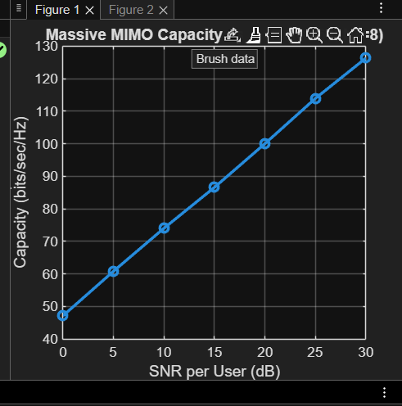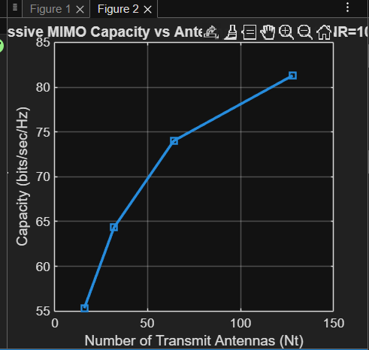

Conclusion:
- Capacity increases with SNR, as higher SNR allows more reliable data transmission.
- Capacity also increases with the number of transmit antennas due to array gain and spatial multiplexing.
- Massive MIMO significantly improves spectral efficiency for multi-user systems.
- The simulation demonstrates the benefits of scaling Nt in next-generation wireless networks like 5G and beyond.

